Stages of Project Implementation
Individual Project №1
Name | David Michael Francis
Discipline | Operating Systems
University | RUDN University, Moscow, Russia
Language | English

Purpose of the work
Learn how to host a site on a GitHub page and complete the first stage of a personal individual project.

Task
- Install the necessary software
- Download Website Theme Template
- Host it on git hosting
- Set the parameter for site URLs
- Place the site template on GitHub pages

1. Install the necessary software
The first step was installing Hugo, the static site generator used to build the website. I downloaded the extended edition (which supports Sass/SCSS) from the official Hugo releases page on GitHub.

screenshot of the Hugo releases page on GitHub, showing the hugo_extended_0.164.0_linux-amd64.deb asset
The file was downloaded to my Downloads folder inside WSL Ubuntu.

terminal output of ls showing the downloaded .deb file
I installed it using apt:
sudo apt install ./hugo_extended_0.164.0_linux-amd64.deb
Once installed, I confirmed the version and that the extended build was active:
hugo version
terminal output showing hugo v0.164.0+extended
I also confirmed Git was installed and configured my identity for commits:
git --version
git config --global user.name "Your Name"
git config --global user.email "your-email@example.com"

2. Download Website Theme Template
Next, I created a new Hugo project and initialised it as a Git repository.
hugo new site blog
cd blog
git init
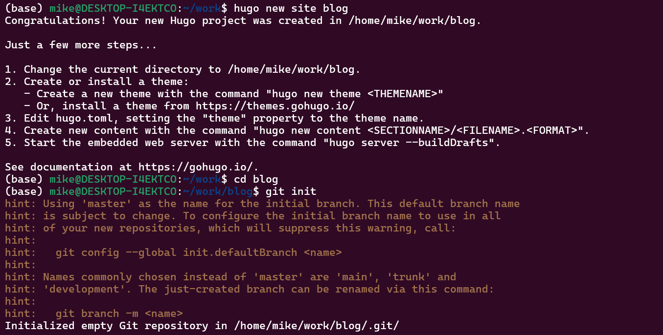
terminal output showing the site scaffold being created
I then chose a theme from the Hugo themes directory and added it as a Git submodule of the project:
git submodule add https://github.com/luizdepra/hugo-coder.git themes/hugo-coder
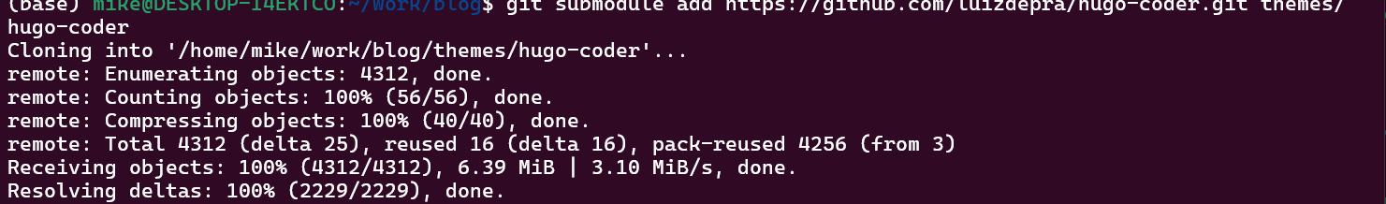
terminal output confirming the theme was cloned successfully
Adding the theme as a submodule keeps it version-controlled separately from the main project, which is the standard way Hugo themes are managed.

3. Host it on git hosting
Before pushing the project online, I created a personal access setup for authentication and previewed the site locally to confirm it built correctly:
hugo server
Once confirmed locally, I created a new empty repository on GitHub to host the project.

“Create a new repository” page on GitHub
I linked my local project to the new GitHub repository and pushed the code:
git add .
git commit -m "Initial Hugo site"
git remote add origin git@github.com:Ushie47/blog.git
git branch -M main
git push -u origin main

terminal output confirming the push succeeded

4. Set the parameter for site URLs
For the site to render correctly once deployed, the baseURL parameter in the Hugo configuration file needed to match the exact URL where GitHub Pages would serve the site.
nano hugo.toml
baseURL = "https://ushie47.github.io/blog/"
I committed and pushed this change:
git add hugo.toml
git commit -m "Set baseURL and site config"
git push
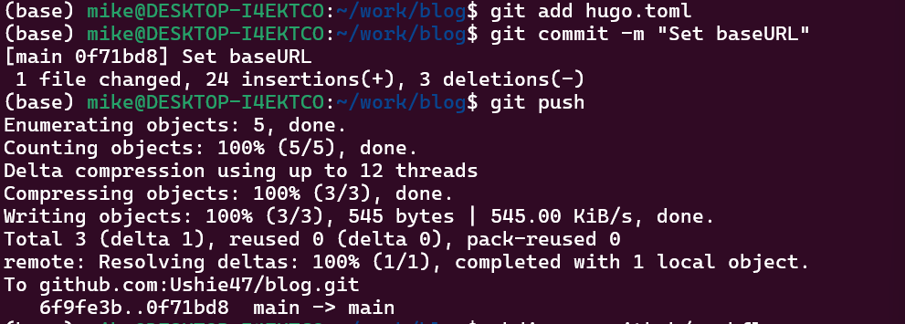
terminal output confirming the push

5. Place the site template on GitHub pages
To deploy the site automatically, I enabled GitHub Pages with the “GitHub Actions” build source, under repository Settings → Pages.

screenshot of the GitHub Pages settings, with Source set to “GitHub Actions”
I then created a deployment workflow file to build and publish the site on every push to the main branch:
mkdir -p .github/workflows
nano .github/workflows/hugo.yml
git add .github/workflows/hugo.yml
git commit -m "Add GitHub Pages deploy workflow"
git push
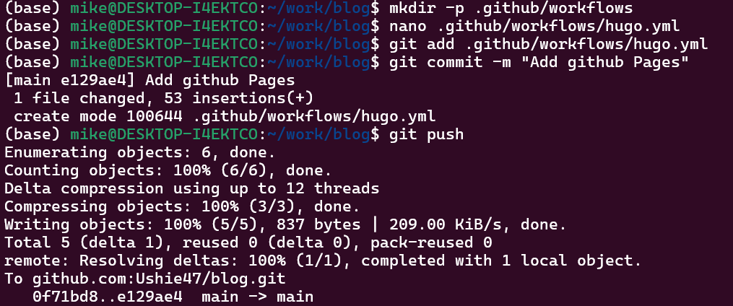
terminal output confirming the push
I monitored the deployment under the repository’s Actions tab.

screenshot of the GitHub Actions run completing successfully
Once the workflow completed, the site went live. 

Conclusion
Through this stage, I learned how to install Hugo, structure a static site project, manage a theme as a Git submodule, configure a project for deployment, and automatically publish a website using GitHub Actions and GitHub Pages. This provided a working foundation for the personal website that will be expanded in later stages of the project.

